Solution Architecture

Date | 29 June 2026
Team ID | xxxxxx
Project Name | OptiCrop: Smart Agricultural Production Optimization Engine
Maximum Marks | 5 Marks

Solution Architecture Diagram:
Provide a high-level visual representation of your solution's architecture. Use the structural layout below as a template to map out your Presentation Layer, Application Layer, and Data Layer. Fill in the specific technologies and components for your project directly into the boxes to create your architectural diagram.

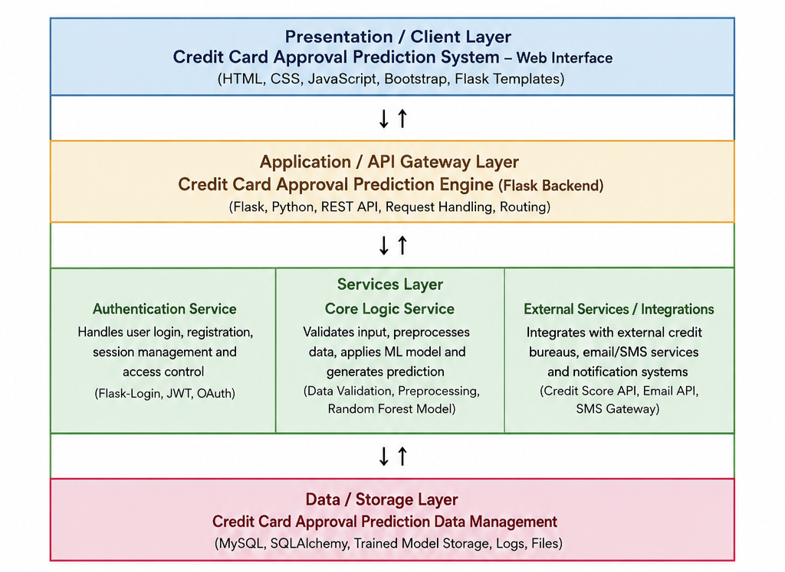
Component Description Table

